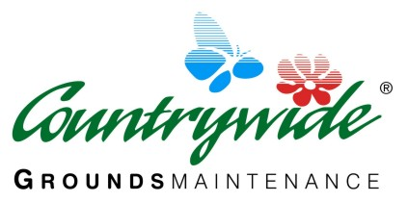

Unit 2 Silverwood
Snowhill
Copthorne
RH10 3EN

Alan Erskine
Lingfield Youth FC
C/O 53 Lincolns Mead
Lingfield
RH7 6TA

26th September 2013

Dear Alan

Thank you for asking us to provide a quotation for grounds maintenance at Lingfield Youth FC

- An initial cut of the grass on the new pitch including will cost £150 plus VAT. Grass cutting will be left in a corner of the field as agreed.
- To roll the grass area using our 2 tonne roller, our price is £60 plus VAT
- Grass cutting of the whole field area using a ride on cylinder mower which will improve the over all condition of the grass will cost £65 plus VAT per cut. This is a cut and drop machine but if done on a regular basis there will be very little grass left on top.

I would recommend once the grass is maintained to a good cutting standard I would carry out a general weed and feed to the field area.

As discussed we are happy to provide a detailed quote for improving drainage and playing surface once the initial work above has been carried out.

As a rough estimate to improve drainage, soil structure and grass quality over this area the cost would be in the region of £5000 however, depending on the specification this could be reduced or increased accordingly.

I hope the above meets with your approval. If you wish to discuss this further please do not hesitate to contact me.

Best regards

Dan Lillywhite
Regional Manager

